Webinar on the COPERT model
- Download and install
Link to download the software: https://copert.emisia.com/copert/download/
Steps to download the free software
- Register as shown below
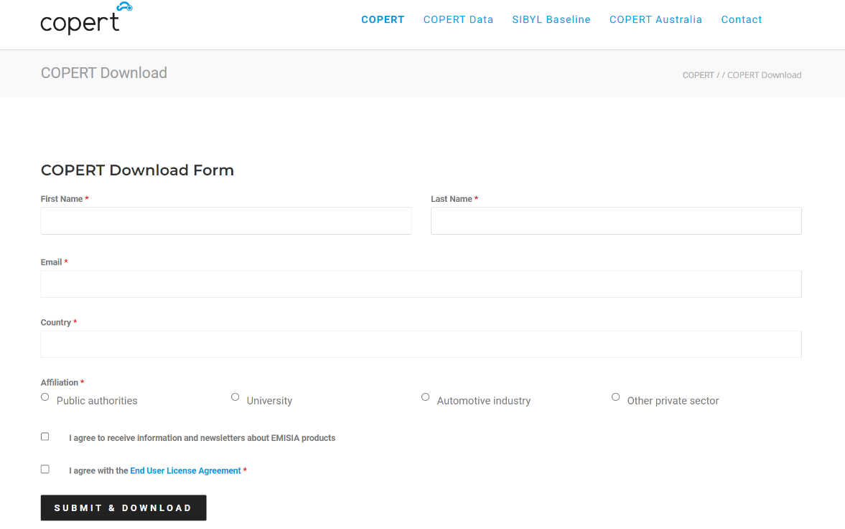
- Submit and start downloading the Copert_V5.7.3.msi file
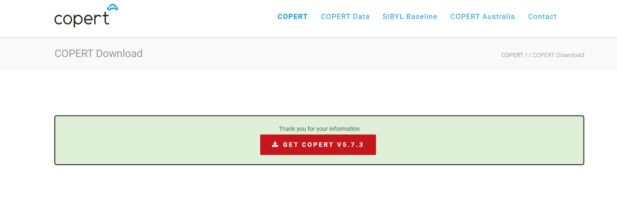
Double-click the file Copert_V5.7.3.msi file to start the installation procedure.
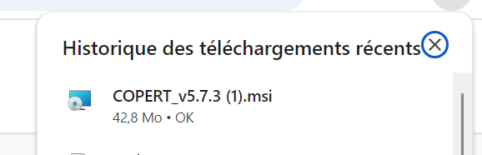
Follow the required steps of the installation.

- Exercises
Exercise 1- Session 5
Part A
Use the Excel file provided named « Session 5 exercise T2 » with a dummy vehicle data fleet for one year to build the database under Copert to estimate GHG emissions with Tier 2.
- Create a new file of the vehicle fleet considering all vehicle categories and standards to start data input manually (with wizard and without wizard) using Tier 2.
- Calculate GHG emissions with Tier 2 then display results on the screen and export to excel file. Open the results excel file to manage the results.
- Modify data (vehicle stock and mileage (mean activity)) in the excel file and save it as « Session 5 exercise T2 revised ».
- Use the import function to import the revised data from the excel file named « Session 5 exercise Tier 2 revised » and recalculate GHG emissions then display results on the screen and export to excel file. Open the results excel file to manage the results.

Part B
Use the Excel file provided named « Session 5 exercise T3 » with a dummy vehicle data fleet for one year to build the database under Copert to estimate GHG emissions with Tier 3.
- Create a new file of the vehicle fleet considering all vehicle categories with their standards, driving conditions and environmental information to start data input manually (with wizard and without wizard) using Tier 3.
- Calculate GHG emissions with Tier 3 then display results on the screen and export to excel file. Open the results excel file to manage the results.
- Modify data (vehicle stock and mileage (mean activity), Speed and road share) in the excel file and save it as « Session 5 exercise T3 revised ».
- Use the import function to import the revised data from the excel file named « Session 5 exercise Tier 3 revised » and recalculate GHG emissions then display results on the screen and export to excel file. Open the results excel file to manage the results.

Exercise 2 – Session 6
Part A
Use the national vehicle fleet given in excel file « Session 6 Exercise T2 T3 National Vehicle Fleet » to build the database on Copert for years 2016-2020 and then calculate GHG emissions for the whole timeseries (2016-2020) series using Tier 2.
- Export input structure to Excel file (version 2010)
- Export emission results to Excel file (version 2010)
Part B
Use the national vehicle fleet given in excel file « Session 6 Exercise T2 T3 National Vehicle Fleet » to build the database on Copert for years 2016-2020 and then calculate GHG emissions for the whole timeseries (2016-2020) series using Tier 3.
- Export input structure to Excel file (version 2010)
- Export emission results to Excel file (version 2010)
Exercise 3 – Session 7
Part A
- Use excel file « Session 7 Exercise T2 Scenario Vehicle Fleet Composition Mileage projection » to estimate emissions for the whole time series 1990-2040 considering the evolution of the national vehicle fleet and the corresponding mileage assumed. Build the database by applying the import function of Copert.
- Export the results in an excel file (version 2010).
- Export input structure to Excel file (version 2010)
Part B
Use excel file « Session 7 Exercise T2 Scenario technology projection» to estimate emissions for the whole time series 1990-2040 considering the evolution of the national vehicle fleet and the corresponding mileage with the new technology introduced. Build the database by applying the import function of Copert.
- Export the results in an excel file (version 2010)
- Export input structure to Excel file (version 2010)

